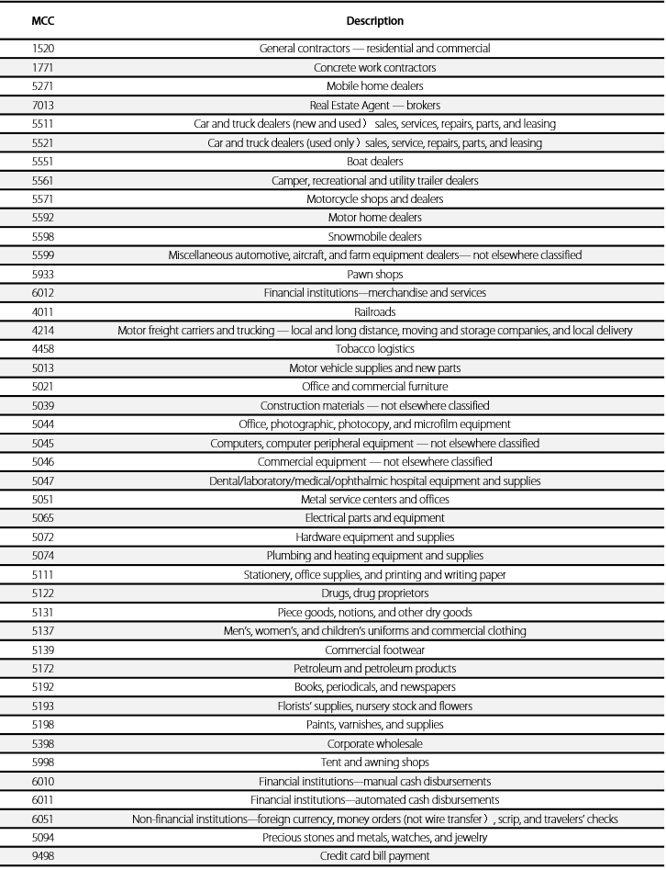

**Appendix : UPI Daily-Consumed MCC List**

Daily-consumed MCCs refer to MCCs **excluding the following MCCs:**